ADVENTURE PLAN TRACKERS
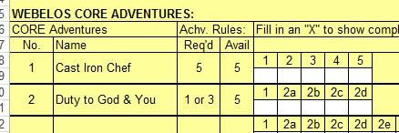
- Tracking Spreadsheets are posted on the USScouts Advancement webpage (http://usscouts.org/advance/cubscout/intro.asp). The spreadsheets were tested by a software developer who said they are so good he sees no reason to develop his own!!
- Utah National Parks Council, also, has Excel spreadsheets posted for all the new Adventure Plan requirements on their Akela's Council BlogSpot.
http://akelascouncil.blogspot.com/search/label/Tracking%20Sheet (The page starts with Arrow of Light scroll down for other ranks)
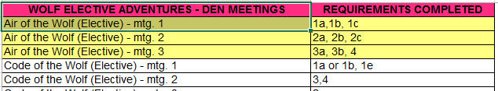
- A spreadsheet that correlates Meetings to Adventure requirements is available on the Utah National Parks' Akela's Council Blogspot at https://www.dropbox.com/s/yb8fweg7etnhqrt/WOLF%20BEAR%20WEBELOS%20REQUIREMENTS%20-%20MTGS.xlsx?dl=0 . It has all the Wolf, Bear, Webelos and AOL Adventure requirements.
These Advancement Spreadsheet workbooks are FREE for Scouters. But be COURTEOUS and observe the following -
PLEASE do not download the files from either site to email or send them digitally to others.
They are for your personal / pack use only. If you would like to share these files with others, please copy / send the link to them and send them to the site so they can print off their own. They would love everyone that wants a copy to get their own copy free. Both USScouts and Utah National Parks receive Ad money based on the number of people visiting the site. That ad money helps keep their websites open. Please help them (us) by encouraging others to visit to obtain files.

